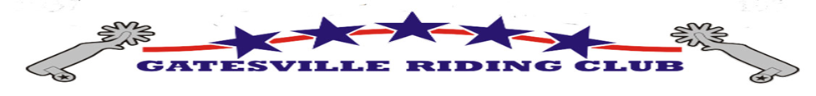
Vendor Application
2019 RAM Rodeo
August 1 – 3

Gates open to the public at 6:00. Rodeo performance starts at 7:30 pm.
Performance runs until approximately 10:30.
Setup is Open Wednesday July 31 and will be scheduled after receipt of the Vendor Application.

Email completed form to gatesvilleridingclub1937@gmail.com
Questions: Teri Campbell Phone: 254-223-7733

- ABSOLUTELY NO FOOD OR DRINK MAY BE SOLD, SAMPLED, OR GIVEN OUT! (Please do not bring in outside food or beverages, full concessions are available on-site throughout the rodeo.)
- Spaces measure approximately 10 feet x 10 feet and are located behind the main grandstand. (View of the arena is obstructed.)
- There is NO ELECTRICITY and NO WATER available for any of the spaces. There is general lighting in the area, but there are no outlets available for use by vendors.
- This is a completely outdoor venue. You must provide your own tent or shade, if you wish.
- You must provide your own tables, chairs, and other fixtures.
- This is a “rain-or-shine” event, with no reschedule date; no refund of deposit.
- The arena and grounds are NOT secure. Any property on the grounds is at the owners’ own risk; GRC is not responsible for theft, damage, or injury.
- Space is limited. If space fills up, we will keep a waiting list.

Cost: $100 for 1- 10’x 10’ space, for all three nights of rodeo performance. $60 for individual nights.
You may reserve additional spaces for larger displays at the same rate.
Includes 2 (two) vendor passes for access to arena/grounds. (Additional passes are $15.00/each.)
Deposit: 50% of the chosen space, due by July 15, 2019.

Name of Business: ___________________________________________________________________

Contact person: _________________________________ Phone number: ______________________

E-mail address: _____________________________________________________________________
Email is very important. We will send you a confirmation and setup schedule!
Description of product to be sold: _____________________________________________________
Number of spaces needed___________________________________________________________
Vendor signature: ____________________________________________Date:_________________

